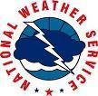
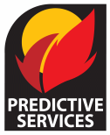
Weather Resources that Aid the NORCAL Burner
- NWS Red Flag Warning-Fire Weather Watch: https://www.wrh.noaa.gov/fire2/cafw
- NWS hourly Tabular and Graphical Forecasts:
  - https://weather.gov
  - Move cursor to the appropriate location on the map.
    - Choose local forecast office.
    - Example: North Central CA or NW CA Coast
  - Scroll down webpage to area map.
    - Double click on map at approximate location for the burn.
  - Scroll down to small map (right side).
    - Refine your location by moving the cursor in the map and double clicking.
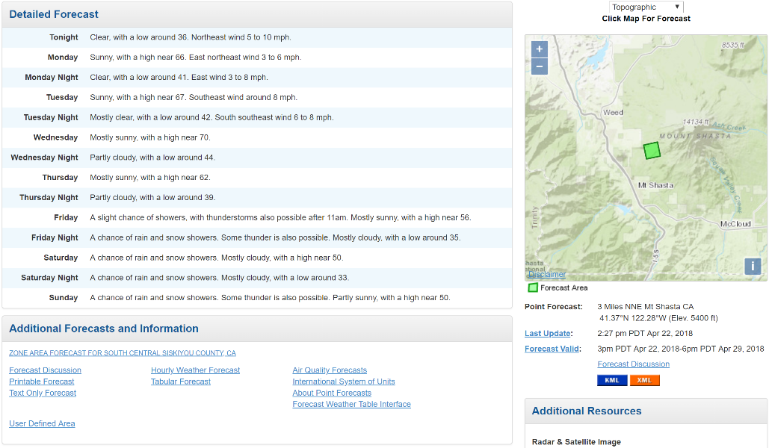
Forecast area location
    - Choose either Hourly Weather Forecast or Tabular Forecast highlighted by the red box.
  - Forecast’s are in 2 day increments. Pick and choose which elements you want to display.
  - Remember to bookmark the webpage for future use.
    - Notice lat/long in the web address.
    - You can change the lat/long when you change project location.

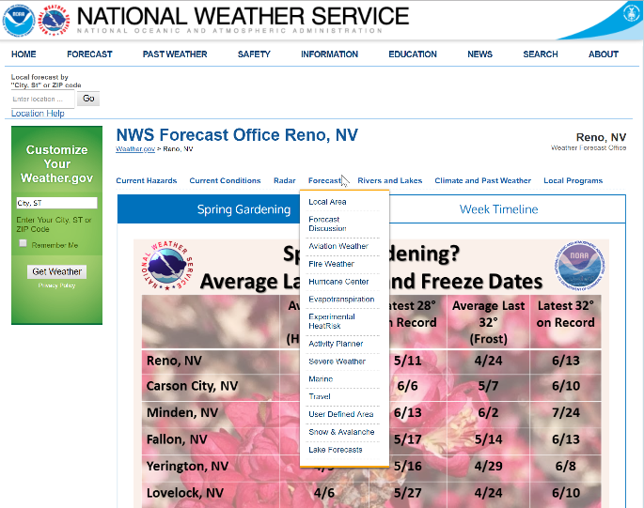
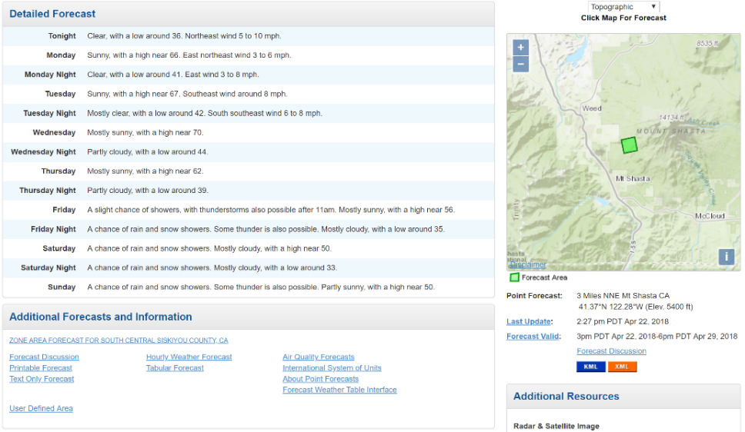
  - NWS Text Discussions: Area Forecast Discussion (2 methods)

  - Fire Weather Planning Forecast Discussion
    - Choose “Fire Weather” in drop down menu.
    - Double click on the map.
    - Or visit https://www.wrh.noaa.gov/fire2/cafw and click on the map.

- North Ops Predictive Service Website: https://gacc.nifc.gov/oncc/predictive/weather/index.htm

Webcast
7-day
Smoke Forecast

- High Resolution Weather Models
  - CANSAC WRF: https://cansac.dri.edu//cansac_output.php?model=wrf
    - 2km domain: Sfc 10m Wind speed or Sfc RH (NW quad)
  - HRRR: https://rapidrefresh.noaa.gov/hrrr/HRRR/Welcome.cgi?dsKey=hrrr_ncep_jet
    - Change domain to NW
    - Weather fields: 10m Wind, 10m wind gust, 2m RH, Composite Reflectivity, total acc precip
  - Tropical Tidbits: https://www.tropicaltidbits.com/analysis/models/
    - Click on Mesoscale tab and choose NAM3km
    - Click on Region tab and choose Southwest
    - Click on Precip/Moisture tab and choose from several useful fields like MSLP & Precip (Rain/Frozen)
- Air Resource Board Met Program: https://www.arb.ca.gov/smp/met/met.htm
  - Choose Air Basin and click on it.
- Missoula Lab Fire Weather Alert System (FWAS): https://weather.firelab.org/fwas/
  - Set your location
  - Name alert
  - Set your watch radius
  - Set expiration time
  - Set weather thresholds
  - Input contact info (cell # or email)

